Tenant Garbage & Recycling Guidelines
Dear Valued Resident,
We are committed to creating a clean and sustainable community for everyone. Below are the proper procedures for garbage disposal and recycling on our property. Thank you for your cooperation in helping keep costs down and our community looking its best.

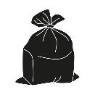 | GARBAGE | 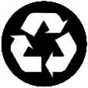 | RECYCLING
- Please be sure to securely bag all your garbage before leaving your unit. This will help prevent spills and odors along your path to the waste station.  - Waste stations are located at both the south and north sides of our property.  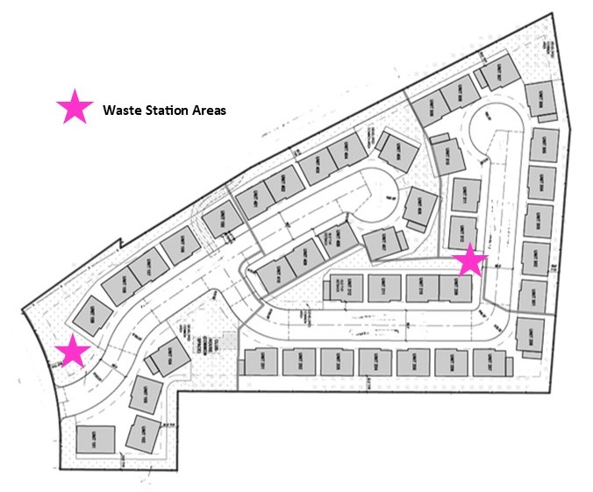  - Large, bulky items like furniture or mattresses should be placed outside the dumpster enclosure.  - Remember to shut container lids when not in use. This will help to reduce litter and pest issues.  - No blocking the front of dumpsters or enclosure gates.  - No overfilling garbage containers. If a container is full, use another garbage container on the property.  - No placing garbage in recycle bins. |  | - Use an old tub or tote bag to collect and carry your recyclables from your unit to the recycle bins.  - Empty out containers and lightly rinse before placing them in recycle bins.  - Place items loose in bins marked for recycling. No need to separate recyclables.  - Be sure to flatten boxes and remove all foam, plastic bags, and shrink wrap.  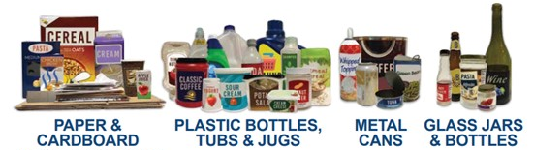  Accepted for Recycling  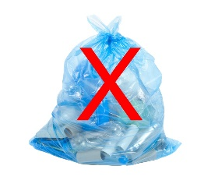  - No Plastic Bags  - No Food or Garbage  - No Batteries  - No Stretch or Bubble Wrap  Learn more at siouxfalls.gov/recycle  or scan the QR code below.  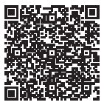

We appreciate your cooperation and participation in the recycling program. For more information or if you have any questions, please contact us at apartment@property.com or 555-555-555.

