Preconstruction Meeting Agenda Instructions

This agenda provides a guideline for discussion items in Preconstruction meetings. Items should be deleted if they do not apply to the project. However, all applicable items should be included.

City Engineering should be contacted to provide new specifications and requirements which should be discussed in Item 8. The topics listed in Item 8 are current for 2026.

This agenda, with a cover letter, shall be completed by the Consultant. The Consultant shall invite the Prime Contractor and the affected utility companies. The Prime Contractor shall invite all subcontractors and suppliers they wish to attend. The Project Manager shall invite all applicable City employees.

In the invitation cover letter, the Consultant should list all paperwork that the Contractor needs to submit prior to construction.

The Consultant shall add all discussion notes from the Preconstruction Meeting to the agenda to create the meeting minutes. A cover letter signed by the Consultant shall be sent with a copy of the meeting minutes, the attendance roster, contractor list, and supplier list to the City, Contractor, Utilities, and all others requesting a copy. Meeting minutes may be distributed by email.

Preconstruction Meeting Agenda

Sioux Falls, South Dakota
CIP No. XXXXX Bid Request No. XX-XXXX
Date: XXXXXXXX, 2026
- Attendance of Preconstruction Conference
- Distribute attendance sheet for everyone to sign.
- Have everyone introduce themselves if needed.
- Contract, Notice to Proceed, Liquidated Damages
a) Date of Contract: XXXX
b) Notice to Proceed Date: XXXX
Contract shall start on the date construction begins, but not later than ten calendar days after notice.
c) Liquidated Damages: Liquidated damages $XX per working day.
Incentives:
d) Contractor Documents: Up to XX sets of no charge documents will be provided.
e) Contractor to inform Engineer a minimum of 48 hours in advance of street closure(s) and detour changes.
Message boards for arterial or selected projects will be in place one week prior to the street closure or construction operations.
f) Engineer will contact City so that a news release may be published.
- Subcontractors
(List of Subcontractors shall be provided by Contractor prior to the Preconstruction Meeting.)
- Plan Sequence and Construction Progress Schedule
- Project Phasing and Work Schedule provided by Contractor:
- Engineer Project Phasing and Work Schedule Comments:
- Contract Requirements:
- Start Date: XXXX
- Completion Date: XXXX
- Calendar/Working Days: XXXX (delete if not applicable)
- Substantial Completion Requirements: XXXX (delete if not applicable)
- Final Completion (completion of punch list items): XXXX This is the start of the warranty period. See General Conditions 5.16
- Interim Date(s): XXXX (delete if not applicable)
- Interim Requirements: XXXX (delete if not applicable)
- Horizontal and Vertical Control
- XXX will provide all construction staking. Twenty-four (24) hour notice required for significant staking.
- Construction Utilities
a) Unless specifically provided for otherwise in specifications, Contractor is responsible for providing all utilities necessary to fully execute his contract.
b) Contractor is responsible for verifying utility information and calling for utility locations.
c) Plan shown utility locations for reference only.
Utility Contacts: (Engineer shall verify that contact information is correct prior to meeting.)
1. | Water Reclamation (Sanitary) | City of Sioux Falls | Shad Hochstein | 941-1163
2. | Water Reclamation (Storm) | City of Sioux Falls | Austin Waldron | 367-3547
3. | Water Maintenance | City of Sioux Falls | Darin McDonnel | 367-8810
4. | Light and Power | City of Sioux Falls | Jerry Jongeling | 373-6979
5. | Traffic | City of Sioux Falls | Heath Hoftiezer | 367-8634
6. | One call center 1-800-781-7474 or 811
7. | Insert any additional utilities included from design
d) Discuss all utility conflicts and relocations.
- Project Meetings
a) Weekly project meeting time and place: XXXX
b) Plan of the day meeting time and place (if required): XXXX (delete if not applicable)
- New Requirements and Critical Issues (Consultant to delete all items that are not applicable to the project. If you’re not sure about something, ask the City's PM. Do not discuss items that do not apply to your project.)
- Manholes/Junction Boxes
  - Ensure good compaction around these structures. Compaction tests will be taken within 4 feet of manholes and junction boxes.
  - No shims or other leveling devices, other than leveling rings provided by the manufacturer, are permitted with use of the adjusting rings.
  - Adjusting rings for sanitary sewer manholes shall be made of expanded polypropylene and shall meet the requirements of AASHTO M306, HS-20 and HS-25. The adjusting ring shall be PRO-RING or approved equal.
  - The annular space between the manhole adjusting rings shall be sealed using the manufacturer’s approved sealant. The sealant shall not shrink upon curing. The sealant shall be M-1 by Chem Link or approved equal.
  - Correction of manhole and junction box adjustments are not to be considered as warranty items – they must be corrected prior to final payment to the Contractor.
- Dewatering
  - Pumping sediment laden water, including ponded stormwater or contaminated trench dewatering, into the storm sewer or off the project site without the use of a flocculation bag or other similar BMP is not permitted and may result in a price deduction.
  - Pumping sediment laden water through inlet protection is not allowed as a BMP.
- Temporary Pedestrian Access Routes (TPAR’s)
  - Federal law requires that pedestrians with disabilities (including visual disabilities) are accommodated during times of construction or improvement.
  - The TPAR will be kept free of any obstructions and hazards, such as holes, debris, mud, snow, construction equipment, traffic control signing, stored materials, etc.
  - Daily inspection of all TPAR’s should be conducted, and cleaning/maintenance performed as necessary.
  - If Audible Information Devices (AID’s) are used, the recorded message must be current/correct at all times. If the TPAR changes in any way, the AID recording must be re-recorded immediately.
  - If an AID is stolen, vandalized, etc. the City will consider reimbursing the Contractor for a replacement through a CCO under the following conditions:
    - The contractor provides the Engineer with a list of serial numbers or other unique identifying information for each AID used on the project, within one day of installing the AID on the project.
    - The Engineer verifies the list of serial numbers match the AIDs installed on the project.
    - The Contractor provides an invoice or other proof of their costs for purchasing and shipping a replacement AID.
    - Reimbursement will be limited to the invoice cost of a replacement AID, shipping, applicable sales tax, and excise tax. Any additional markups for overhead and profit will not be allowed.
    - Additional materials, tools, labor, accessories, or other necessary items and costs associated with installing a replacement AID will be incidental to the project.
- Weed Control
  - Contractor is responsible for weed control in both disturbed and undisturbed areas of the project. Payment shall be lump sum.
  - Weed control is expected to be applied before weeds approach 24 inches; however, weeds exceeding 24 inches in height shall be removed by mowing within one working day of discovery.
  - Weeds listed as Statewide Noxious Weeds as defined by the DANR or declared by the County shall immediately be sprayed/removed upon discovery.
  - The City reserves the right to assess a price deduction if the Contractor fails to remove weeds from the project area in a timely manner.
- Concrete Curing
  - Curing compound must be applied no later than 30 minutes after the finishing operations have been completed or after removing curing blankets if they are used. If curing compound is applied in two applications, the second will be applied within 30 minutes after the first coat.
  - Curing compound must be sprayed uniformly and should look as white as a sheet of paper when applied properly. See below for examples of improper application:
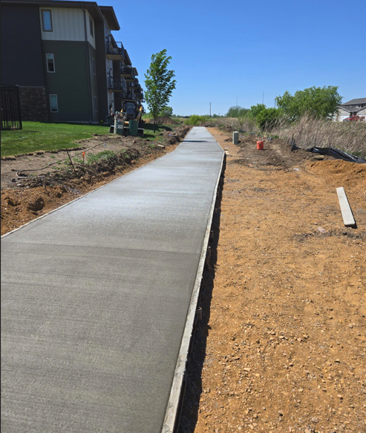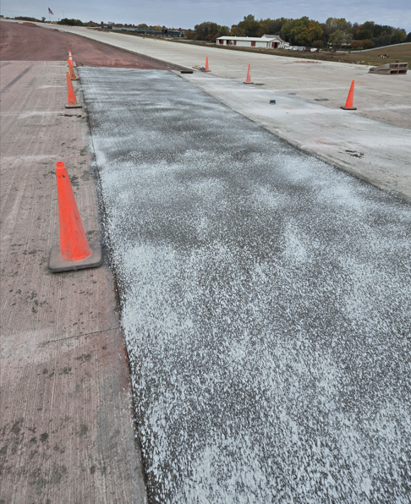
- Water Valves should only be opened/closed by City personnel.
- Water Main Bacteriological Test (Bac-T) Update
  - Two Bac-T samples shall be collected by City personnel from the new watermain by one of the following approved methods:
    - One set of samples collected after disinfection and final flushing, with a second set of samples collected a minimum of 16 hours after the first set; or,
    - After disinfection and final flushing, the watermain shall remain unused for a minimum of 16 hours. Two consecutive sets of samples will then be collected a minimum of 15 minutes apart without flushing the main while the sample taps are left running.
- Milling
  - Exercise caution when milling adjacent to existing concrete to remain in place.
  - Contractor will be responsible for damage caused to the adjacent concrete by either removal/replacement at no cost to the City, or by a price adjustment to be assessed. Determination which occurs is at the sole discretion of the City.
- One Call Notification Change
  - State law update to go into effect on July 1, 2026
  - The forty-eight-hour notification period begins at 12:01 a.m. the day after notice is submitted to the notification center, excluding any Saturday, Sunday, or legal holiday of the state.
  - Example: If Kyle calls in a locate ticket at 6am Tuesday and another at 3pm Tuesday, the 48 hour notice will not start until 12:01am Wednesday morning for both tickets. The locates would then be good Friday morning at 12:01 am.
- Consultant to add additional items as appropriate for each project
- Discussion of Plans (Dismiss those not interested in plan compliance information.)

- Equipment and Materials
a) Contractor shall submit a list of materials suppliers at Preconstruction Meeting.
b) Furnish equipment, components, or materials as named in specifications. Requests for product substitutions should be considered only under circumstances outlined in specifications.
- Testing
a) XXX will provide materials testing.
b) Owner will pay for the materials testing. Owner responsibility will include the first test and a backup test if required.
c) Contractor will pay for all additional materials testing until plan compliance is achieved, if testing is required beyond the backup test. Contractor will also provide and pay for all other testing specified by the contract.
d) Contractor shall provide 24-hour notice for all testing with a 1-hour confirmation for concrete pours.
e) Lab test reports, concrete, compaction reports, etc.
(1) Identify station and offset on all test reports.
- Additions or Deletions to Contract
a) The Owner, through the Engineer, may request changed or extra work by the use of change orders. Change orders shall be executed prior to performing work.
b) Additions/subtractions of existing contract bid items will be made at current unit prices.
- Coordination with Landowners
- Engineer and owner to provide coordination information to the affected property owners and residents with monthly project webpage updates. (delete/revise as appropriate)
- Landowner coordination by the Contractor as required.
- Sprinklers System Care letter needs to be sent to all affected landowners.

- Contacts and Chain of Command
- Owner: City of Sioux Falls
Primary Contact:
Mailing Address:
Telephone: Mobile:
After-Hours Phone Number:
- Engineer:
Project Manager:
Mailing Address:
Telephone: Mobile:
After-Hours Phone Number:
Project Engineer—On-Site:
Telephone: Mobile:
After-Hours Phone Number:
Project Technician/Inspector—On-Site:
Telephone: Mobile:
After-Hours Phone Number:
The Consultant shall provide written documentation if changes are made to the project staff.
- Material Testing Engineer:
Project Testing Manager:
Primary Contact:
Mailing Address:
Telephone: Mobile:
After-Hours Phone Number:
- Contractor:
Primary Contact:
Mailing Address:
Telephone: Mobile:
After-Hours Phone Number:
Project Superintendent:
Mailing Address:
Telephone: Mobile:
After-Hours Phone Number:
The Contractor will provide written documentation if changes are made to the Project Superintendent.
- Traffic Control:
Primary Contact:
Mailing Address:
Telephone: Mobile:
After-Hours Phone Number:
- Payment to Contractor
a) Pay requests shall be made biweekly based on work complete. On SRF-funded projects, payment will be made monthly with pay requests due the first Friday of the month and payment made the last Monday of the month.
b) Final payment will be made in accordance with the General Conditions.
c) No payment will be made for equipment stored off site.
d) Engineer will prepare pay estimates.
e) Does Contractor elect to review and sign all progress estimates prior to submittal?
Yes No Other Comments:
- Correlation and/or Interpretation of Documents
a) If discrepancies occur between Drawings and Specifications, request Engineer’s interpretation.
b) The Inspector cannot authorize deviations from the contract documents without the Engineer’s approval.
- Differing Site Conditions and/or Out of Scope Work
- If the Contractor encounters site conditions that differ from those shown in the contract documents, he must notify the Engineer in writing before the site is disturbed and before the affected work is performed. Reference Section 4.2 of the General Conditions.
- If any out of scope work is required or requested, the cost of said work must be agreed to in writing prior to the commencement of said work when there are no bid items for the work in the contract.
- Disadvantage Business Enterprise (DBE) (delete this from the agenda if there are not DBE requirements on the project. If there are DBE requirements, make sure the City PM invites Tiffany Lonning and Jake Rysdon to the Preconstruction meeting)
a) Tiffany Lonning (367-8704) and/or Jake Rysdon (367-8829) will present DBE requirements at the Preconstruction Meeting.
- Safety
- The Contractor is responsible for safety on the project, both for their own staff and for the general public. The Contractor shall also provide safe access on the project for the Engineer and Inspector.

Attendance List
Name | Company | Cell | Email

List of Contractors
 | Company | Supt./Forman | Cell | Email
Grading
Traffic Control
Underground
Electrical
Erosion Control
Asphalt
Concrete
Other

List of Suppliers
 | Company | Address/Pit Data | Phone | Email
Asphalt
Concrete
Gravel
Borrow
Storm Pipe
Sanitary Pipe
Water Pipe
Lights/Signals
Other

